Практическая работа №2
Приложение на Spring
Общее задание
Вам необходимо разработать приложение, используя типовую архитектуру и технологии Spring. Оно должно иметь три слоя (данные, логика, представление) и предоставлять средства для работы с базой данных (включая добавление, редактирование и удаление данных).
Настоятельно рекомендуется использовать систему контроля версий и управления исходным кодом (например, GitHub).
Вы можете выбрать любую IDE.
Задание 1
Выберите любую предметную область и разработайте модель, содержащую как минимум две сущности с несколькими свойствами.
Сформируйте скрипт для создания и заполнения базы данных для вашей модели.
Да, вы можете использовать те же модели и скрипты, которые использовали ранее.

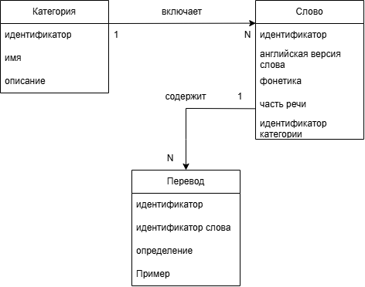
Диаграмма сущностей проекта - PDOM

CREATE TABLE category (
id BIGSERIAL PRIMARY KEY,
name VARCHAR(100) NOT NULL UNIQUE,
description VARCHAR(500)
);

CREATE TABLE word (
id BIGSERIAL PRIMARY KEY,
english_word VARCHAR(100) NOT NULL,
phonetics VARCHAR(100) NOT NULL,
part_of_speech VARCHAR(30) NOT NULL,
category_id BIGINT NOT NULL,
CONSTRAINT uq_word_lexical_entry
UNIQUE (english_word, phonetics, part_of_speech, category_id),
CONSTRAINT chk_word_part_of_speech
CHECK (part_of_speech IN (
'noun', 'verb', 'adjective', 'adverb', 'pronoun',
'preposition', 'conjunction', 'numeral', 'interjection', 'article'
)),
CONSTRAINT fk_word_category
FOREIGN KEY (category_id)
REFERENCES category(id)
ON DELETE RESTRICT
ON UPDATE CASCADE
);

CREATE TABLE translation (
id BIGSERIAL PRIMARY KEY,
word_id BIGINT NOT NULL,
meaning VARCHAR(200) NOT NULL,
example TEXT,
CONSTRAINT fk_translation_word
FOREIGN KEY (word_id)
REFERENCES word(id)
ON DELETE CASCADE
ON UPDATE CASCADE
);

CREATE INDEX idx_word_category ON word(category_id);
CREATE INDEX idx_translation_word ON translation(word_id);

INSERT INTO category (id, name, description) VALUES
(1, 'Food', 'Еда и напитки'),
(2, 'Travel', 'Путешествия и транспорт'),
(3, 'Business', 'Бизнес и работа'),
(4, 'General', 'Общая лексика'),
(5, 'Sports', 'Спорт');

INSERT INTO word (id, english_word, phonetics, part_of_speech, category_id) VALUES
(1, 'apple', '[ˈæp.əl]', 'noun', 1),
(2, 'banana', '[bəˈnɑː.nə]', 'noun', 1),
(3, 'ticket', '[ˈtɪk.ɪt]', 'noun', 2),
(4, 'airport', '[ˈeə.pɔːt]', 'noun', 2),
(5, 'meeting', '[ˈmiː.tɪŋ]', 'noun', 3),
(6, 'record', '[ˈrek.ɔːd]', 'noun', 4),
(7, 'record', '[rɪˈkɔːd]', 'verb', 4),
(8, 'run', '[rʌn]', 'verb', 4),
(9, 'light', '[laɪt]', 'noun', 4),
(10, 'light', '[laɪt]', 'adjective', 4),
(11, 'swim', '[swɪm]', 'verb', 5);

INSERT INTO translation (id, word_id, meaning, example) VALUES
(1, 1, 'яблоко', 'I eat an apple every day.'),
(2, 2, 'банан', 'Bananas are yellow.'),
(3, 3, 'билет', 'I need to buy a ticket.'),
(4, 3, 'штраф', 'He got a parking ticket.'),
(5, 4, 'аэропорт', 'The airport is far from the city.'),
(6, 5, 'встреча', 'We have a meeting at 3 p.m.'),
(7, 5, 'совещание', 'The meeting lasted two hours.'),
(8, 6, 'запись', 'She kept a record of every expense.'),
(9, 6, 'пластинка', 'He bought an old record.'),
(10, 7, 'записывать', 'Please record the interview.'),
(11, 8, 'бежать', 'I run every morning.'),
(12, 8, 'управлять (компанией)', 'She runs a successful company.'),
(13, 9, 'свет', 'The room was filled with light.'),
(14, 10, 'лёгкий', 'This bag is very light.'),
(15, 10, 'светлый', 'She has light hair.'),
(16, 11, 'плавать', 'I swim twice a week.');

SELECT setval('category_id_seq', (SELECT MAX(id) FROM category));
SELECT setval('word_id_seq', (SELECT MAX(id) FROM word));
SELECT setval('translation_id_seq', (SELECT MAX(id) FROM translation));

SELECT
c.name AS category,
w.english_word,
w.phonetics,
w.part_of_speech,
t.meaning,
t.example
FROM word w
JOIN category c ON c.id = w.category_id
JOIN translation t ON t.word_id = w.id
ORDER BY c.name, w.english_word, w.part_of_speech, t.id;

Задание 2
Разработайте слой данных в виде Java Beans для вашей модели и подготовьте их к использованию с Hibernate.
Создайте дополнительные классы и файлы конфигурации Hibernate (при необходимости).
Слой данных таблицы word
package com.vocab.entity;
import jakarta.persistence.*;
import java.io.Serializable;
import java.util.ArrayList;
import java.util.List;
@Entity
@Table(name = "word")
public class Word implements Serializable {
private static final long serialVersionUID = 1L;
@Id
@GeneratedValue(strategy = GenerationType.IDENTITY)
private Long id;
@Column(name = "english_word", nullable = false, length = 100)
private String englishWord;
@Column(name = "phonetics", nullable = false, length = 100)
private String phonetics;
@Column(name = "part_of_speech", nullable = false, length = 50)
private String partOfSpeech;
@ManyToOne(fetch = FetchType.EAGER, optional = false)
@JoinColumn(name = "category_id", nullable = false)
private Category category;
@OneToMany(mappedBy = "word", cascade = CascadeType.ALL, orphanRemoval = true)
private List<Translation> translations = new ArrayList<>();
public Word() {
}
public Long getId() {
return id;
}
public void setId(Long id) {
this.id = id;
}
public String getEnglishWord() {
return englishWord;
}
public void setEnglishWord(String englishWord) {
this.englishWord = englishWord;
}
public String getPhonetics() {
return phonetics;
}
public void setPhonetics(String phonetics) {
this.phonetics = phonetics;
}
public String getPartOfSpeech() {
return partOfSpeech;
}
public void setPartOfSpeech(String partOfSpeech) {
this.partOfSpeech = partOfSpeech;
}
public Category getCategory() {
return category;
}
public void setCategory(Category category) {
this.category = category;
}
public List<Translation> getTranslations() {
return translations;
}
public void setTranslations(List<Translation> translations) {
this.translations = translations;
}
}

Слой данных таблицы category
package com.vocab.entity;
import jakarta.persistence.*;
import java.io.Serializable;
import java.util.ArrayList;
import java.util.List;
@Entity
@Table(name = "category")
public class Category implements Serializable {
private static final long serialVersionUID = 1L;
@Id
@GeneratedValue(strategy = GenerationType.IDENTITY)
private Long id;
@Column(name = "name", nullable = false, unique = true, length = 100)
private String name;
@Column(name = "description", length = 500)
private String description;
@OneToMany(mappedBy = "category")
private List<Word> words = new ArrayList<>();
public Category() {
}
public Long getId() {
return id;
}
public void setId(Long id) {
this.id = id;
}
public String getName() {
return name;
}
public void setName(String name) {
this.name = name;
}
public String getDescription() {
return description;
}
public void setDescription(String description) {
this.description = description;
}
public List<Word> getWords() {
return words;
}
public void setWords(List<Word> words) {
this.words = words;
}
}

Слой данных таблицы translation
package com.vocab.entity;
import jakarta.persistence.*;
import java.io.Serializable;
@Entity
@Table(name = "translation")
public class Translation implements Serializable {
private static final long serialVersionUID = 1L;
@Id
@GeneratedValue(strategy = GenerationType.IDENTITY)
private Long id;
@ManyToOne(fetch = FetchType.EAGER, optional = false)
@JoinColumn(name = "word_id", nullable = false)
private Word word;
@Column(name = "meaning", nullable = false, length = 200)
private String meaning;
@Column(name = "example")
private String example;
public Translation() {
}
public Long getId() {
return id;
}
public void setId(Long id) {
this.id = id;
}
public Word getWord() {
return word;
}
public void setWord(Word word) {
this.word = word;
}
public String getMeaning() {
return meaning;
}
public void setMeaning(String meaning) {
this.meaning = meaning;
}
public String getExample() {
return example;
}
public void setExample(String example) {
this.example = example;
}
}

CategoryRepository
package com.vocab.repository;
import com.vocab.entity.Category;
import org.springframework.data.domain.Page;
import org.springframework.data.domain.Pageable;
import org.springframework.data.jpa.repository.JpaRepository;
import org.springframework.stereotype.Repository;
import java.util.List;
@Repository
public interface CategoryRepository extends JpaRepository<Category, Long> {
List<Category> findAllByOrderByNameAsc();
boolean existsByName(String name);
Page<Category> findAllByOrderByNameAsc(Pageable pageable);
}

WordRepository
package com.vocab.repository;
import com.vocab.entity.Word;
import org.springframework.data.domain.Page;
import org.springframework.data.domain.Pageable;
import org.springframework.data.jpa.repository.JpaRepository;
import org.springframework.data.jpa.repository.Query;
import org.springframework.data.repository.query.Param;
import org.springframework.stereotype.Repository;
import java.util.List;
@Repository
public interface WordRepository extends JpaRepository<Word, Long> {
@Query("SELECT DISTINCT w FROM Word w LEFT JOIN FETCH w.category LEFT JOIN FETCH w.translations ORDER BY w.englishWord")
List<Word> findAllWithDetails();
@Query("SELECT DISTINCT w FROM Word w LEFT JOIN FETCH w.category LEFT JOIN FETCH w.translations WHERE LOWER(w.englishWord) LIKE LOWER(:query) ORDER BY w.englishWord")
List<Word> searchWithDetails(@Param("query") String query);
// Для пагинации с JOIN FETCH нужно использовать countQuery
@Query(value = "SELECT DISTINCT w FROM Word w LEFT JOIN FETCH w.category LEFT JOIN FETCH w.translations ORDER BY w.englishWord",
countQuery = "SELECT COUNT(w) FROM Word w")
Page<Word> findAllWithDetailsPaged(Pageable pageable);
@Query(value = "SELECT DISTINCT w FROM Word w LEFT JOIN FETCH w.category LEFT JOIN FETCH w.translations WHERE LOWER(w.englishWord) LIKE LOWER(:query) ORDER BY w.englishWord",
countQuery = "SELECT COUNT(w) FROM Word w WHERE LOWER(w.englishWord) LIKE LOWER(:query)")
Page<Word> searchWithDetailsPaged(@Param("query") String query, Pageable pageable);
}

TranslationRepository
package com.vocab.repository;
import com.vocab.entity.Translation;
import org.springframework.data.jpa.repository.JpaRepository;
import org.springframework.stereotype.Repository;
import java.util.List;
@Repository
public interface TranslationRepository extends JpaRepository<Translation, Long> {
List<Translation> findAllByWordId(Long wordId);
}

Задание 3
Реализуйте бизнес-слой на основе Spring Beans для доступа к данным и их редактирования.
WordService
package com.vocab.service;
import com.vocab.entity.Category;
import com.vocab.entity.Translation;
import com.vocab.entity.Word;
import com.vocab.repository.CategoryRepository;
import com.vocab.repository.WordRepository;
import org.springframework.beans.factory.annotation.Autowired;
import org.springframework.stereotype.Service;
import org.springframework.transaction.annotation.Transactional;
import java.util.List;
import org.springframework.data.domain.Page;
import org.springframework.data.domain.PageRequest;
import org.springframework.data.domain.Pageable;
import org.springframework.data.domain.Sort;
@Service
@Transactional
public class WordService {
@Autowired
private WordRepository wordRepository;
@Autowired
private CategoryRepository categoryRepository;
public List<Word> findAll() {
return wordRepository.findAllWithDetails();
}
public List<Word> search(String query) {
if (query == null || query.trim().isEmpty()) {
return findAll();
}
return wordRepository.searchWithDetails("%" + query.trim() + "%");
}
public Word findById(Long id) {
return wordRepository.findById(id).orElse(null);
}
public void create(String englishWord, String phonetics, String partOfSpeech,
Long categoryId, String meaning, String example) {
Category category = categoryRepository.findById(categoryId).orElseThrow();
Word word = new Word();
word.setEnglishWord(englishWord.trim());
word.setPhonetics(phonetics.trim());
word.setPartOfSpeech(partOfSpeech);
word.setCategory(category);
Translation translation = new Translation();
translation.setMeaning(meaning.trim());
translation.setExample(example);
translation.setWord(word);
word.getTranslations().add(translation);
wordRepository.save(word);
}
public void update(Long id, String englishWord, String phonetics, String partOfSpeech,
Long categoryId, Long translationId, String meaning, String example) {
Word word = wordRepository.findById(id).orElseThrow();
Category category = categoryRepository.findById(categoryId).orElseThrow();
word.setEnglishWord(englishWord.trim());
word.setPhonetics(phonetics.trim());
word.setPartOfSpeech(partOfSpeech);
word.setCategory(category);
// Обновляем первый перевод (для простоты UI)
if (!word.getTranslations().isEmpty()) {
Translation t = word.getTranslations().get(0);
t.setMeaning(meaning.trim());
t.setExample(example);
} else {
Translation translation = new Translation();
translation.setMeaning(meaning.trim());
translation.setExample(example);
translation.setWord(word);
word.getTranslations().add(translation);
}
wordRepository.save(word);
}
public void delete(Long id) {
wordRepository.deleteById(id);
}
public Page<Word> findAllPaged(int page, int size) {
Pageable pageable = PageRequest.of(page, size, Sort.by("englishWord"));
return wordRepository.findAllWithDetailsPaged(pageable);
}
public Page<Word> searchPaged(String query, int page, int size) {
if (query == null || query.trim().isEmpty()) {
return findAllPaged(page, size);
}
Pageable pageable = PageRequest.of(page, size, Sort.by("englishWord"));
return wordRepository.searchWithDetailsPaged("%" + query.trim() + "%", pageable);
}
}

CategoryService
package com.vocab.service;
import com.vocab.entity.Category;
import com.vocab.repository.CategoryRepository;
import org.springframework.beans.factory.annotation.Autowired;
import org.springframework.stereotype.Service;
import org.springframework.transaction.annotation.Transactional;
import java.util.List;
import org.springframework.data.domain.Page;
import org.springframework.data.domain.PageRequest;
import org.springframework.data.domain.Pageable;
import org.springframework.data.domain.Sort;
@Service
@Transactional
public class CategoryService {
@Autowired
private CategoryRepository categoryRepository;
public List<Category> findAll() {
return categoryRepository.findAll();
}
public Category create(String name, String description) {
Category category = new Category();
category.setName(name.trim());
category.setDescription(description);
return categoryRepository.save(category);
}
public void delete(Long id) {
categoryRepository.deleteById(id);
}
public Page<Category> findAllPaged(int page, int size) {
Pageable pageable = PageRequest.of(page, size, Sort.by("name"));
return categoryRepository.findAllByOrderByNameAsc(pageable);
}
}

TranslationService
package com.vocab.service;
public class TranslationService {
}

Задание 4
Реализуйте слой представления с помощью Spring MVC.
VocabController
package com.vocab.controller;
import com.vocab.entity.Category;
import com.vocab.entity.Word;
import com.vocab.service.CategoryService;
import com.vocab.service.WordService;
import org.slf4j.Logger;
import org.slf4j.LoggerFactory;
import org.springframework.beans.factory.annotation.Autowired;
import org.springframework.stereotype.Controller;
import org.springframework.ui.Model;
import org.springframework.web.bind.annotation.*;
import org.springframework.data.domain.Page;
@Controller
public class VocabController {
// Логгер для отладки в консоли
private static final Logger log = LoggerFactory.getLogger(VocabController.class);
@Autowired
private WordService wordService;
@Autowired
private CategoryService categoryService;
@GetMapping("/")
public String index(@RequestParam(defaultValue = "0") int page,
@RequestParam(defaultValue = "5") int size,
@RequestParam(defaultValue = "0") int catPage,
@RequestParam(defaultValue = "10") int catSize, // Показываем по 10 категорий
Model model) {
Page<Word> wordsPage = wordService.findAllPaged(page, size);
Page<Category> categoriesPage = categoryService.findAllPaged(catPage, catSize);
model.addAttribute("wordsPage", wordsPage);
model.addAttribute("categoriesPage", categoriesPage);
model.addAttribute("word", new Word());
model.addAttribute("editingWord", null);
return "index";
}
@GetMapping("/search")
public String search(@RequestParam(required = false) String query,
@RequestParam(defaultValue = "0") int page,
@RequestParam(defaultValue = "5") int size,
@RequestParam(defaultValue = "0") int catPage,
@RequestParam(defaultValue = "10") int catSize,
Model model) {
Page<Word> wordsPage = wordService.searchPaged(query, page, size);
Page<Category> categoriesPage = categoryService.findAllPaged(catPage, catSize);
model.addAttribute("wordsPage", wordsPage);
model.addAttribute("categoriesPage", categoriesPage);
model.addAttribute("word", new Word());
model.addAttribute("editingWord", null);
model.addAttribute("searchQuery", query);
return "index";
}
// Сохранение/Обновление слова
@PostMapping("/word/save")
public String saveWord(@RequestParam(required = false) Long id,
@RequestParam String englishWord,
@RequestParam String phonetics,
@RequestParam String partOfSpeech,
@RequestParam Long categoryId,
@RequestParam String meaning,
@RequestParam(required = false) String example) {
log.info(">>> Сохранение слова: '{}'", englishWord);
if (id == null || id == 0) {
wordService.create(englishWord, phonetics, partOfSpeech, categoryId, meaning, example);
} else {
// При обновлении передаем null вместо translationId, сервис сам найдет первый перевод
wordService.update(id, englishWord, phonetics, partOfSpeech, categoryId, null, meaning, example);
}
return "redirect:/"; // Перенаправление на главную после сохранения
}
// Подготовка формы редактирования
@GetMapping("/word/edit/{id}")
public String editWord(@PathVariable Long id, Model model) {
log.info(">>> Редактирование слова с ID: {}", id);
Word word = wordService.findById(id);
model.addAttribute("words", wordService.findAll());
model.addAttribute("categories", categoryService.findAll());
model.addAttribute("word", word);
model.addAttribute("editingWord", word); // Флаг, что мы в режиме редактирования
return "index";
}
// Удаление слова
@GetMapping("/word/delete/{id}")
public String deleteWord(@PathVariable Long id) {
log.info(">>> Удаление слова с ID: {}", id);
wordService.delete(id);
return "redirect:/";
}
// Создание категории
@PostMapping("/category/save")
public String saveCategory(@RequestParam String name,
@RequestParam(required = false) String description) {
log.info(">>> Создание категории: '{}'", name);
categoryService.create(name, description);
return "redirect:/";
}
// Удаление категории
@GetMapping("/category/delete/{id}")
public String deleteCategory(@PathVariable Long id) {
log.info(">>> Удаление категории с ID: {}", id);
categoryService.delete(id);
return "redirect:/";
}
}

Index.html
<!DOCTYPE html>
<html xmlns:th="http://www.thymeleaf.org">
<head>
<meta charset="UTF-8">
<title>Учет английских слов (Spring Boot)</title>
<style>
body { font-family: Arial, sans-serif; margin: 24px; color: #333; }
h1, h2 { color: #2c3e50; }
table { border-collapse: collapse; width: 100%; margin-bottom: 20px; }
th, td { border: 1px solid #ddd; padding: 8px; text-align: left; }
th { background-color: #f2f2f2; }
.form-box { background: #f9f9f9; padding: 15px; border: 1px solid #ddd; margin-bottom: 20px; border-radius: 5px; }
input, select, textarea { margin-bottom: 10px; padding: 5px; width: 100%; box-sizing: border-box; }
button, .btn { background-color: #4CAF50; color: white; padding: 8px 15px; border: none; cursor: pointer; border-radius: 4px; text-decoration: none; display: inline-block; margin-right: 5px;}
.btn-danger { background-color: #f44336; }
.btn-edit { background-color: #2196F3; }
</style>
</head>
<body>
<h1>Учет английских слов (Spring Boot)</h1>
<!-- ================= ПОИСК ================= -->
<div class="form-box">
<form th:action="@{/search}" method="get" style="display: flex; gap: 10px; align-items: center;">
<label style="width: auto; margin: 0;"><b>Поиск по слову:</b></label>
<input type="text" name="query" th:value="${searchQuery}" placeholder="Например: record" style="width: 300px; margin: 0;"/>
<input type="hidden" name="page" value="0"/>
<input type="hidden" name="size" value="5"/>
<button type="submit">Найти</button>
<a th:href="@{/}" class="btn" style="background-color: #9e9e9e;">Сбросить</a>
</form>
</div>
<!-- ================= ТАБЛИЦА СЛОВ ================= -->
<h2>Слова (Всего: <span th:text="${wordsPage.totalElements}">0</span>)</h2>
<table>
<thead>
<tr>
<th>Слово</th>
<th>Транскрипция</th>
<th>Часть речи</th>
<th>Категория</th>
<th>Значения и примеры</th>
<th>Действия</th>
</tr>
</thead>
<tbody>
<tr th:each="w : ${wordsPage.content}">
<td th:text="${w.englishWord}"></td>
<td th:text="${w.phonetics}"></td>
<td th:text="${w.partOfSpeech}"></td>
<td th:text="${w.category != null} ? ${w.category.name} : 'Без категории'"></td>
<td>
<div th:each="t : ${w.translations}">
<b th:text="${t.meaning}"></b><br/>
<i th:if="${t.example != null}" th:text="'Пример: ' + ${t.example}" style="color: #666;"></i>
</div>
</td>
<td>
<a th:href="@{/word/edit/{id}(id=${w.id})}" class="btn btn-edit">Ред.</a>
<a th:href="@{/word/delete/{id}(id=${w.id})}" class="btn btn-danger" onclick="return confirm('Удалить слово?')">Удалить</a>
</td>
</tr>
</tbody>
</table>
<!-- Пагинация для слов -->
<div th:if="${wordsPage.totalPages > 1}" style="margin: 20px 0; text-align: center;">
<a th:if="${wordsPage.hasPrevious()}"
th:href="@{/(page=${wordsPage.number - 1}, size=${wordsPage.size})}"
class="btn">← Назад</a>
<span style="margin: 0 15px; font-weight: bold;">
Страница <span th:text="${wordsPage.number + 1}">1</span> из <span th:text="${wordsPage.totalPages}">1</span>
</span>
<a th:if="${wordsPage.hasNext()}"
th:href="@{/(page=${wordsPage.number + 1}, size=${wordsPage.size})}"
class="btn">Вперед →</a>
</div>
<!-- ================= ФОРМА ДОБАВЛЕНИЯ/РЕДАКТИРОВАНИЯ СЛОВА ================= -->
<h2 th:text="${editingWord != null} ? 'Редактирование слова' : 'Новое слово'"></h2>
<div class="form-box">
<form th:action="@{/word/save}" method="post">
<input type="hidden" name="id" th:value="${editingWord != null} ? ${editingWord.id} : 0"/>
<label>Английское слово:</label>
<input type="text" name="englishWord" th:value="${editingWord != null} ? ${editingWord.englishWord} : ''" required/>
<label>Транскрипция:</label>
<input type="text" name="phonetics" th:value="${editingWord != null} ? ${editingWord.phonetics} : ''" required/>
<label>Часть речи:</label>
<select name="partOfSpeech">
<option value="noun" th:selected="${editingWord != null and editingWord.partOfSpeech == 'noun'}">noun</option>
<option value="verb" th:selected="${editingWord != null and editingWord.partOfSpeech == 'verb'}">verb</option>
<option value="adjective" th:selected="${editingWord != null and editingWord.partOfSpeech == 'adjective'}">adjective</option>
<option value="adverb" th:selected="${editingWord != null and editingWord.partOfSpeech == 'adverb'}">adverb</option>
<option value="pronoun" th:selected="${editingWord != null and editingWord.partOfSpeech == 'pronoun'}">pronoun</option>
<option value="preposition" th:selected="${editingWord != null and editingWord.partOfSpeech == 'preposition'}">preposition</option>
<option value="conjunction" th:selected="${editingWord != null and editingWord.partOfSpeech == 'conjunction'}">conjunction</option>
<option value="numeral" th:selected="${editingWord != null and editingWord.partOfSpeech == 'numeral'}">numeral</option>
<option value="interjection" th:selected="${editingWord != null and editingWord.partOfSpeech == 'interjection'}">interjection</option>
<option value="article" th:selected="${editingWord != null and editingWord.partOfSpeech == 'article'}">article</option>
</select>
<label>Категория:</label>
<select name="categoryId" required>
<option value="">-- выберите --</option>
<!-- ИСПРАВЛЕНО: используем categoriesPage.content вместо categories -->
<option th:each="c : ${categoriesPage.content}" th:value="${c.id}" th:text="${c.name}"
th:selected="${editingWord != null and editingWord.category != null and editingWord.category.id == c.id}"></option>
</select>
<label>Основной перевод:</label>
<input type="text" name="meaning"
th:value="${editingWord != null and editingWord.translations != null and !editingWord.translations.isEmpty()} ? ${editingWord.translations[0].meaning} : ''" required/>
<label>Пример использования:</label>
<textarea name="example" rows="2"
th:text="${editingWord != null and editingWord.translations != null and !editingWord.translations.isEmpty()} ? ${editingWord.translations[0].example} : ''"></textarea>
<button type="submit">Сохранить</button>
<a th:href="@{/}" class="btn" style="background-color: #9e9e9e;">Отмена</a>
</form>
</div>
<!-- ================= ТАБЛИЦА КАТЕГОРИЙ ================= -->
<h2>Категории (Всего: <span th:text="${categoriesPage.totalElements}">0</span>)</h2>
<table>
<thead>
<tr>
<th>Название</th>
<th>Описание</th>
<th>Действия</th>
</tr>
</thead>
<tbody>
<tr th:each="c : ${categoriesPage.content}">
<td th:text="${c.name}"></td>
<td th:text="${c.description}"></td>
<td>
<a th:href="@{/category/delete/{id}(id=${c.id})}" class="btn btn-danger" onclick="return confirm('Удалить категорию?')">Удалить</a>
</td>
</tr>
</tbody>
</table>
<!-- Пагинация для категорий -->
<div th:if="${categoriesPage.totalPages > 1}" style="margin: 20px 0; text-align: center;">
<a th:if="${categoriesPage.hasPrevious()}"
th:href="@{/(catPage=${categoriesPage.number - 1}, catSize=${categoriesPage.size})}"
class="btn">← Назад</a>
<span style="margin: 0 15px; font-weight: bold;">
Страница <span th:text="${categoriesPage.number + 1}">1</span> из <span th:text="${categoriesPage.totalPages}">1</span>
</span>
<a th:if="${categoriesPage.hasNext()}"
th:href="@{/(catPage=${categoriesPage.number + 1}, catSize=${categoriesPage.size})}"
class="btn">Вперед →</a>
</div>
<!-- ================= ФОРМА ДОБАВЛЕНИЯ КАТЕГОРИИ ================= -->
<div class="form-box">
<h3>Добавить категорию</h3>
<form th:action="@{/category/save}" method="post">
<label>Название:</label>
<input type="text" name="name" required/>
<label>Описание:</label>
<textarea name="description" rows="2"></textarea>
<button type="submit">Добавить</button>
</form>
</div>
</body>
</html>

Задание 5
Добейтесь того, чтобы всё это вместе заработало…
Заработало на localhost:8080.
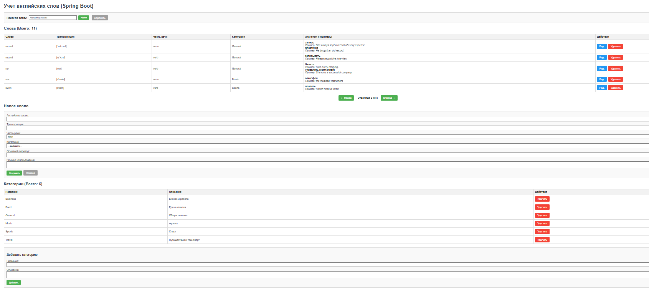
Общий вид
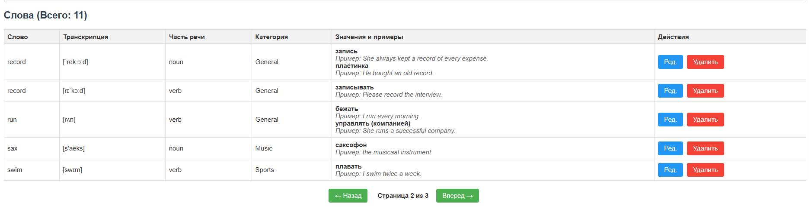
Пагинация
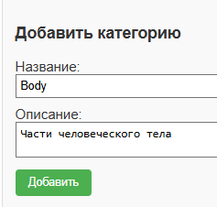
Добавление новой категории
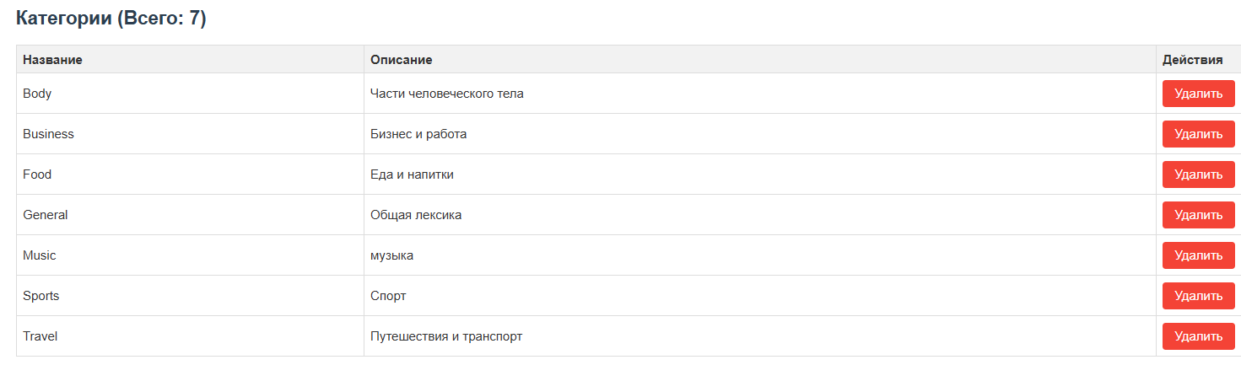
Отображение добавленной новой категории
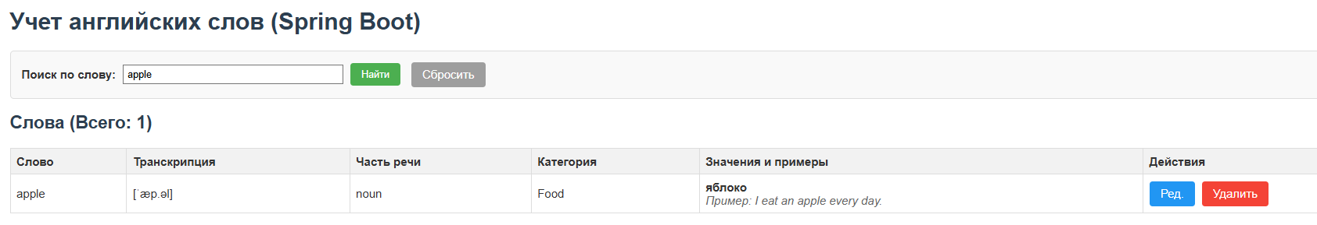
Поиск по слову
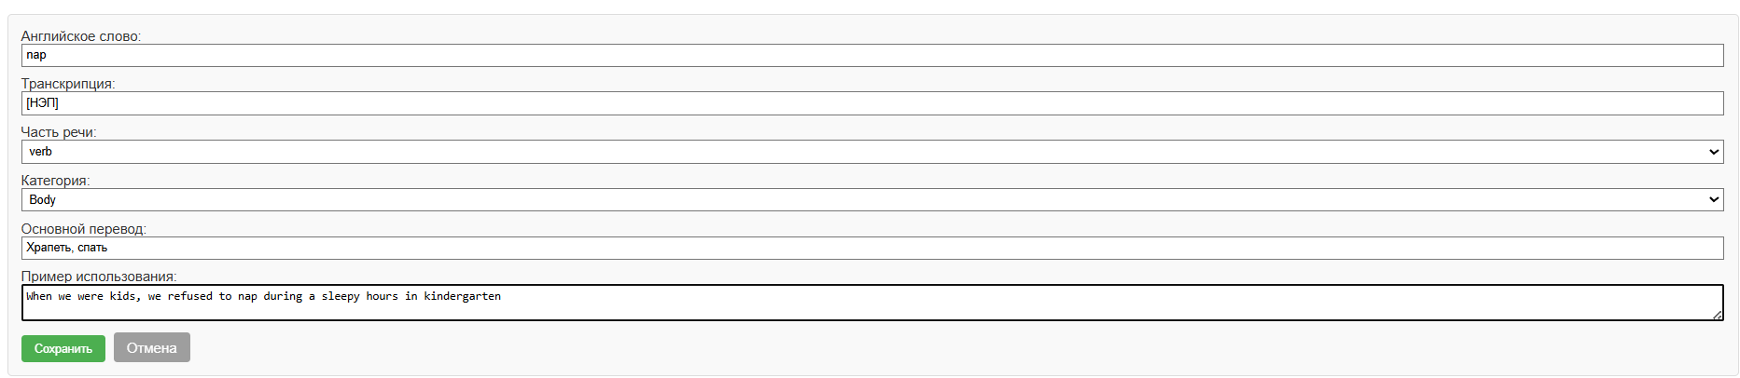
Добавление нового слова
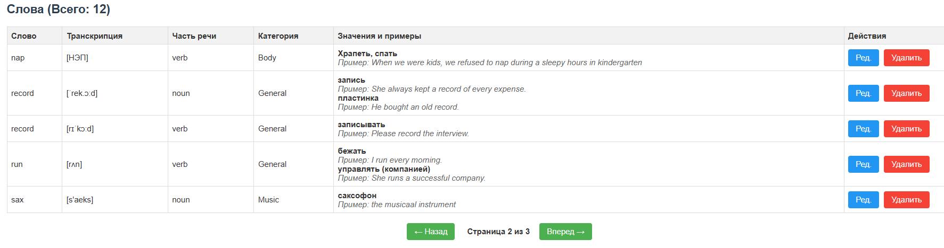
Показ нового слова

